Chapter 16: Manager Information and Technology

16.1 A Winning Hand for Caesars
If you enjoy gambling and want to be pampered, the Las Vegas Strip is the place for you. The four-mile stretch is home to some of the world’s most lavish hotels and casinos, each competing for its share of the 40 million visitors who pack the city each year. The Strip is a smorgasbord of attractions. At the luxurious Mirage, you can witness the eruption of a seventy-foot volcano every quarter hour. The five-star Bellagio resort boasts a $300 million art collection (including Picassos and Van Goghs). There are star-studded shows, upscale retailers, and posh restaurants with award-winning chefs. You can relax at pools and spas or try your luck in the casinos.
Figure 16.1
Caesars Entertainment, formerly called Harrah’s Entertainment, has become an industry leader in the gaming and entertainment industry by effectively using technology.

Source: Jason Patrick Ross/Shutterstock.com
So how does a gaming and entertainment company compete in this environment? If you’ve ever been to Las Vegas, you know that a lot of them erect mammoth, neon-bathed, brick-and-mortar casino resorts. Most, however, do what Caesars does: they invest heavily in technology to transform the way they engage their guests. Marketers at Caesars use technology to collect information about the casino’s customers and then use the information to entice the same people to return. Does the strategy work? Caesars is the world’s largest casino entertainment company in the world.
Throughout this chapter, we’ll discuss the information needs of Caesars’s top executives, managers, and other employees. We’ll examine the ways in which the company uses technology to collect data and process them into information that can be used at every level of the organization.

16.2 Data versus Information

Learning Objectives
- Distinguish between data and information.
- Define “information system” (IS) and identify the tasks of information systems managers.
- Identify the tasks handled by information systems managers.
- Compare the information needs of top managers, middle managers, and first-line managers.
- Describe the advantages of an enterprise resource planning (ERP) system.
Caesars has been collecting and storing data about customers for almost three decades. According to a senior marketing executive, when Caesars started collecting data about its customers, the company had no means of turning these data into marketing decisions. In other words, Caesars was collecting a lot of data but not necessarily any information. So what’s the difference?
As an example, suppose that you want to know how you’re doing in a particular course. So far, you’ve taken two twenty-question multiple-choice tests. On the first, you got questions 8, 11, and 14 wrong; on the second, you did worse, missing items 7, 15, 16, and 19. The items that you got wrong are merely data
Unprocessed facts.
—unprocessed facts. What’s important is your total score. You scored 85 on the first exam and 80 on the second. These two numbers constitute information
Data that have been processed or turned into some useful form.
—data that have been processed, or turned into some useful form. Knowing the questions that you missed simply supplied you with some data for calculating your scores.
Now let’s fast-forward to the end of the semester. At this point, in addition to taking the two tests, you’ve written two papers and taken a final. You got a 90 and 95 on the papers and a 90 on the final. You now have more processed data, but you still want to organize them into more useful information. What you want to know is your average grade for the semester. To get the information you want, you need yet more data—namely, the weight assigned to each graded item. Fortunately, you’ve known from day one that each test counts 20 percent, each paper 10 percent, and the final exam 40 percent. A little math reveals an average grade of 87.
Though this is the information you’re interested in, it may be mere data to your instructor, who may want different information: an instructor who intends to scale grades, for example, will want to know the average grade for the entire class. You’re hoping that the class average is low enough to push your average of 87 up from a B+ to an A- (or maybe even an A—it doesn’t hurt to hope for the best). The moral of the story is that what constitutes information at one stage can easily become data at another; one person’s information can be another person’s data.
As a rule, you want information; data are good only for generating the information. So, how do you convert data into information that’s useful in helping you make decisions and solve problems? That’s the question we’ll explore in the next section.

Information Systems
To gather and process data into information and distribute it to people who need it, organizations develop an information system (IS)
Computer system for gathering and processing data into information and distributing it to people who need it.
—the combination of technologies, procedures, and people who collect and distribute the information needed to make decisions and coordinate and control company-wide activities. In most large organizations, the IS is operated by a senior management team that includes a chief information officer (CIO)
Senior executive who oversees information and telecommunications systems.
who oversees information and telecommunications systems. There may also be a chief technology officer
High-level executive who reports to the CIO and oversees information technology planning and implementation.
who reports to the CIO and oversees IT planning and implementation. As for information managers
Manager with responsibility for determining the information needs of members of the organization and meeting those needs.
, their tasks include the following:
- Determining the information needs of members of the organization
- Collecting the appropriate data
- Applying technology to convert data into information
- Directing the flow of information to the right people

Differences in Information Needs
The job is complicated by the fact that information needs vary according to different levels, operational units, and functional areas. Consider, for instance, the information needs of managers at several levels:
- Top managers need information for planning, setting objectives, and making major strategic decisions.
- Middle managers need information that helps them allocate resources and oversee the activities under their control.
- First-line managers require information that helps them supervise employees, oversee daily operations, and coordinate activities.
Figure 16.2 illustrates a hypothetical hierarchy of information needs at Caesars. The president, for example, needs information to determine whether profitability is up or down or if the organization is facing any new competitive threats. At the vice-presidential level, executives need information that will help them in controlling and planning for specific areas of operations. The VP of casino operations, for example, might need to know which operations are most profitable—slots, table games, or other gaming activities. The VP of hotel operations might want to know whether room revenues are going up or down.
The information needs of middle-level and lower-level managers are different still. The slot-machine manager might want to know whether the placement of machines on the casino floor affects profitability. The poker manager might want to know whether all table games comply with state regulations. At a lower level, the pit manager (who’s in charge of table games in a particular area) needs to know whether there’s a card-counter at his blackjack table or whether a dealer’s activities are suspicious.
Even at a given level, information needs can vary. A manager on the hotel side of the business, for instance, doesn’t care much about profitability at the poker tables, while a pit manager doesn’t have much use for hotel housekeeping reports. The reports that an accountant needs would hardly be the same as those needed by a human resources manager.
Figure 16.2 Information Needs and Flows
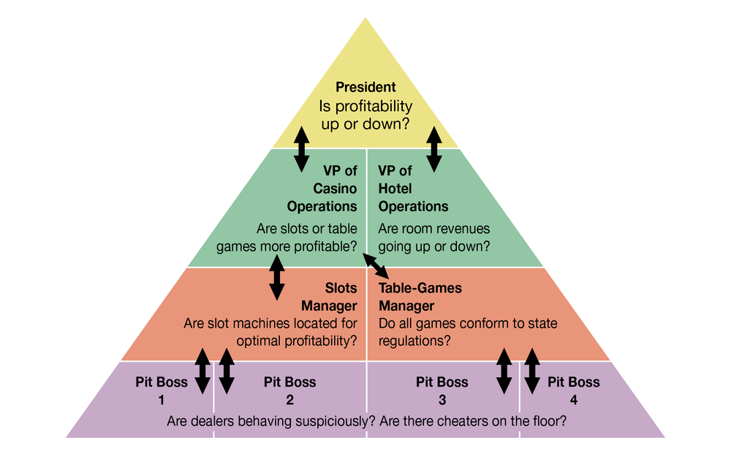
Source: FlatWorld

The Need to Share Information
Having stressed the differences in information needs, we should pause to remind ourselves that the managerial levels, operations, and functions of every organization are intertwined, to a greater or lesser degree. If you’ll glance again at Figure 16.2, you’ll be reminded that organizations need to share information, that information must flow, and that it must flow in both directions—bottom-up and top-down. At Caesars, for instance, both casino and hotel managers are concerned about security, which is also of interest to managers in different functional areas. Information supplied by the security group is obviously vital to managers in the gaming areas, but HR managers also need it to screen potential employees. Marketing information is clearly important to both casino and hotel operations: to maximize overall profits, the company uses marketing data to fill hotel rooms with customers who spend big in the casinos.
Caesars’s information needs entail more than allowing individuals in a given casino to share information—information has to be shared among all of Caesars’s thirty-nine casinos. Thus, Caesars relies on an integrated IT system that allows real-time communication among all its properties. Installing the system (in the mid-1990s) was complicated, and not everyone in the organization liked the idea. Some managers felt that information sharing threatened their independence. Others, including some in the IT group, doubted that a large number of separate IT systems could be adequately integrated. To get everyone on board, John Bushy, then senior VP of information technology, pledged that he wouldn’t cut his hair until the system was up and running. By the time it was operational in 1997, Bushy had hair down to his shoulders, but it was worth it: Caesars’s ability to share real-time information across all its properties has been a major factor in the company’s success.

Enterprise Systems
Many large and mid-size companies rely on a highly integrated system called an enterprise resource planning (ERP) system
Integrated computer system used to channel information to multiple users.
to channel information to multiple users. To understand what an ERP system does, forget about the P for planning (it really doesn’t have much to do with planning) and the R for resource (it’s an imprecise term). Focus on the E for enterprise. An ERP system integrates the computer needs of all activities across the enterprise into a single system that serves all users. Such broad integration isn’t a simple task, and you wouldn’t be the first person to wonder whether it wouldn’t be easier to give each department its own computer system. Salespeople, for example, need a system that tracks sales and generates sales reports. Meanwhile, manufacturing personnel don’t need to track sales but do need to track inventory. What’s the problem with stand-alone computer systems? Quite simply, users in various departments can’t share information or communicate with each other.

What If You Don’t Have ERP?
Imagine that you’re a sales manager for a fairly large manufacturing company that produces and sells treadmills. Like every other department in the organization, you have your own computer system. A local sporting-goods store orders one hundred treadmills through a regional sales representative. It’s your job to process the order. It wouldn’t be much of a problem for you to go into your computer and place the order. But how would you know if the treadmills were actually in stock and when they could be delivered? How would you know if the customer’s credit was any good? You could call the warehouse and ask if the treadmills are in stock. If they are, you’d tell the warehouse manager that you’re placing an order and hope that the treadmills are still in stock by the time your order gets there two days later. While you’re at it, you’d better ask for an expected delivery date. As a final precaution, you should probably call the finance department and ask about your customer’s credit rating. So now you’ve done your job, and it can hardly be your fault that because the cost of manufacturing treadmills has gone up, accounting has recommended an immediate price increase that hasn’t shown up in your computer system yet.

What If You Do Have ERP?
Wouldn’t it be easier if you had an ERP system like the one illustrated in Figure 16.3—one that lets you access the same information as every other department? Then you could find out the number of treadmills in stock, the expected delivery date, your customer’s credit rating, and the current selling price—without spending most of the day exchanging phone calls, emails, text messages, and faxes. You’d be in a better position to decide whether you can give your customer credit, and you could promise delivery (at a correct price) on a specified date. Then, you’d enter the order into the system. The information that you entered would be immediately available to everyone else. The warehouse would know what needs to be shipped, to whom, and when. The accounting department would know that a sale had been made, the dollar amount, and where to send the bill. In short, everyone would have up-to-date information, and no one would have to reinput any data.
Figure 16.3 ERP System
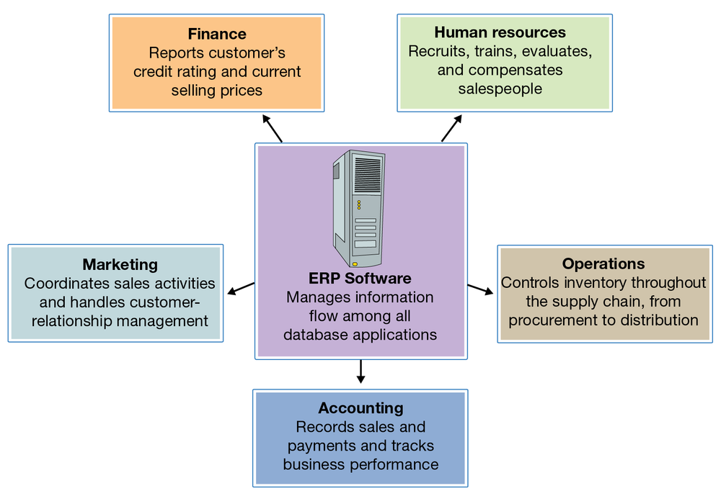
Source: FlatWorld

Key Takeaways
- Data are unprocessed facts. Information is data that have been processed or turned into some useful form.
- To gather and process data into information and distribute it to people who need it, an organization develops an information system (IS)—the combination of technologies, procedures, and people who collect and distribute the information needed to make decisions and to coordinate and control company-wide activities.
- In most large organizations, the information system is operated by a senior management team that includes a chief information officer (CIO) who oversees information and telecommunications systems.
- There may also be a chief technology officer who reports to the CIO and oversees IT planning and implementation.
- The tasks of information managers include the following:
  - Determining the information needs of people in the organization
  - Collecting the appropriate data
  - Applying technology to convert data into information
  - Directing the flow of information to the right people
- The job is complicated by the fact that information needs vary according to different levels, operational units, and functional areas.
- In addition, information must be shared. To channel information to multiple users, large and mid-size companies often rely on a highly integrated system called an enterprise resource planning (ERP) system.
- An ERP system integrates the computer needs of all business activities across the enterprise into a single computer system that serves all users.
Before going to the next section of this chapter, take a few minutes to take an online quiz to test your knowledge of the material covered in this section. Quizzes can be found by clicking on the Self-Study tab in the online reader.

Exercises
- Using the college-application process as an example, explain the difference between data and information. Identify the categories of data that you supplied on your college application and the information generated from them by the admissions department.
- Consider these three positions at Starbucks: retail store manager (in charge of the day-to-day operations at one store), district manager (responsible for the operations at multiple stores), and president of Starbucks North America (in charge of operations throughout the United States, Canada, and Mexico). Identify the information needs of managers at each level.
- In what ways could a large automobile dealership, with a service shop and a body shop, benefit from an ERP system?

16.3 Managing Data

Learning Objectives
- Explain how IS managers capture, store, and analyze data.
- Explain the purpose of data mining.
Did you ever think about how much data you yourself generate? Just remember what you went through to start college. First, you had to fill out application forms asking you about test scores, high school grades, extracurricular activities, and finances, plus demographic data about you and your family. Once you’d picked a college, you had to supply data on your housing preferences, the curriculum you wanted to follow, and the party who’d be responsible for paying your tuition. When you registered for classes, you gave more data to the registrar’s office. When you arrived on campus, you gave out still more data to have your ID picture taken, to get your computer and phone hooked up, to open a bookstore account, and to buy an on-campus food-charge card. Once you started classes, data generation continued on a daily basis: your food card and bookstore account, for example, tracked your various purchases, and your ID tracked your comings and goings all over campus. And you generated grades.
And all these data apply to just one aspect of your life. You also generated data every time you used your credit card and your cell phone. Who uses all these data? How are they collected, stored, analyzed, and distributed in organizations that have various reasons for keeping track of you?

Data and Databases
To answer such questions, let’s go back to our Caesars example. As we’ve seen, Caesars collects a vast amount of data. Its hotel system generates data when customers make reservations, check in, buy food and beverages, purchase stuff at shops, attend entertainment events, and even relax at the spa. In the casino, customers apply for rewards programs, convert cash to chips (and occasionally chips back to cash), try their luck at the tables and slots, and get complimentary drinks. Then, there are the data generated by the activities of the company itself: employees, for instance, generate payroll and benefits data, and retail operations generate data every time they buy or sell something. Moreover, if we added up all these data, we’d have only a fraction of the amount generated by the company’s gaming operations.
How does Caesars handle all these data? First of all, it captures and stores them in several databases
Electronic collection of related data accessible to various users.
—electronic collections of related data that can be accessed by various members of the organization. Think of databases as filing cabinets that can hold massive amounts of organized information, such as revenues and costs from hotel activities, casino activities, and events reservations at each of Caesars facilities.

Warehousing and Mining Data
What if a retailer wants to target customers who generate a lot of revenue, by using a program designed to entice return visits? How would it identify and contact these people? Theoretically, it could search through the relevant databases—those that hold customer-contact information (such as name and address) and information about customer activity (recent purchases and so on). It would be a start, perhaps, but it wouldn’t be very efficient. First of all, it would be time-consuming. Plus, what if the same data weren’t stored in a similar fashion in each database? In that case, it would be quite hard to combine the data in a meaningful way. To address this problem, the store’s managers will rely on a system like the one illustrated in Figure 16.4, which calls for moving all the relevant data into a data warehouse
Centralized database that stores data from several databases so they can be easily analyzed.
—a centralized database in which data from several databases are consolidated and organized so that they can be easily analyzed.
Figure 16.4 The Data Mining Process
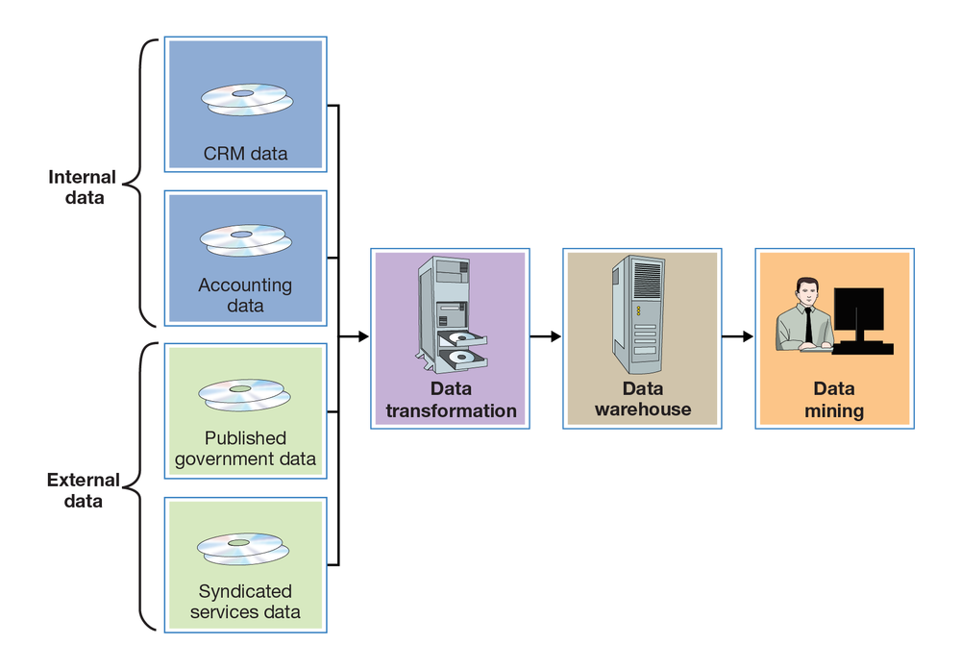
Source: FlatWorld

Data Mining
With the data in one central location, management can find out everything it needs to about a particular group of customers. It can also use the data to address some pretty interesting questions. Why do people come to our store? How can we keep customers coming back? How can we increase the number of visits per customer? How can we increase the amount they spend on each visit? What incentives (such as discount coupons, special sales) do our customers like most? To come up with answers to these questions, they’ll perform a technique called data mining
Technique used to search and analyze data to reveal patterns and trends that can be used to predict future behavior.
—the process of searching and analyzing large amounts of data to reveal patterns and trends that can be used to predict future behavior.

Data Mining and Customer Behavior
By data-mining its customer-based data warehouse, a company can discover previously unknown relationships between the general behavior of its customers and that of a certain group of customers (namely, the most profitable ones). Then, it can design incentives to appeal specifically to those people who will generate the most profit for the company.
Figure 16.5
Caesars collects data on its customers by using players’ rewards cards to gather information and to track betting behavior.

Source: Tupungato/Shutterstock.com
To get a better idea of how data mining works, let’s simplify a description of the process at Caesars. First, we need to know how the casino gathered the data to conduct its preliminary analysis. Most customers who play the slots use a Caesars Total Rewards card that offers incentives based on the amount of money that they wager on slot machines, video poker, and table games. To get the card, a customer must supply some personal information, such as name, address, and phone number. From Caesars’s standpoint, the card is extremely valuable because it can reveal a lot about the user’s betting behavior: actual wins and losses, length of time played, preferred machines, average amount per bet, non-gaming spending, and—most important—the speed of buttons pushed. As you can reference in Figure 16.4, Caesars’s primary data source was internal—generated by the company itself rather than provided by an outside source—and drew on a marketing database developed for customer relationship management (CRM).
What does the casino do with the data that it’s mined? Caesars was most interested in “first trippers”—first-time casino customers. In particular, it wanted to know which of these customers should be enticed to return. By analyzing the data collected from players’ Total Rewards card applications and from customers’ actual play at the casino (even if for no more than an hour), Caesars could develop a profile of a profitable customer. Now, when a first-timer comes into any of its casinos and plays for a while, Caesars can instantly tell whether they fit the profitable-customer profile. To lure these people back for return visits, it makes generous offers of free or reduced-rate rooms, meals, entertainment, or free plays (the incentive of choice for Caesars’s preferred customers). These customers make up 26 percent of all of Caesars’s customers and generate 82 percent of its revenues. Surprisingly, they’re not the wealthy high rollers to whom Caesars had been catering for years. Most of them are regular working people or retirees with available time and income and a fondness for slots. They generally stop at the casino on the way home from work or on a weekend night and don’t stay overnight. They enjoy the thrill of gambling, and you can recognize them because they’re the ones who can’t push the button or pump tokens in fast enough.

Key Takeaways
- Organizations capture and store data in databases—electronic collections of related data that can be accessed by various people in the organization.
- To facilitate data analysis, IS managers may move data from various databases into a data warehouse—a centralized database in which data are consolidated and organized for efficient analysis.
- To come up with answers to a huge range of questions, managers perform a technique called data mining—the process of searching and analyzing large amounts of data to reveal patterns and trends that can be used to predict future behavior.
Before going to the next section of this chapter, take a few minutes to take an online quiz to test your knowledge of the material covered in this section. Quizzes can be found by clicking on the Self-Study tab in the online reader.

Exercise
- Caesars uses data mining to identify its most profitable customers and predict their future behavior. It then designs incentives to appeal specifically to these customers. Do you see any ethical problems with this process? Is it ethical to encourage people to gamble? Explain your answer.

16.4 Types of Information Systems

Learning Objectives
- Discuss ways in which an IS can be designed to meet the needs of individuals at various organizational levels.
- Describe a decision support system.
- Explain how managers use an executive information system.
- Describe the purpose of an expert system.
- Define the term “artificial intelligence.”
As we saw earlier, different managers, operational units, and functional areas have different information needs. That’s why organizations often tailor information systems to meet particular needs. To design marketing programs, for instance, marketing managers rely on summary information gleaned from a dedicated customer-relationship management system. Such a system isn’t very helpful, however, to middle- or top-level managers, who need systems to help them carry out their oversight and planning responsibilities. Let’s look at some of the widely available information systems designed to support people at the operational and upper-management levels.

Operations Support Systems
Operations support systems (Information system used by lower-level managers to assist them in running day-to-day operations and making routine decisions) are generally used by managers at lower levels of the organization—those who run day-to-day business operations and make fairly routine decisions. They may be transaction processing systems, process control systems, or design and production systems.

Transaction Processing Systems
Most of an organization’s daily activities are recorded and processed by its transaction processing system
Information system used to record and process an organization’s daily activities or transactions.
, which receives input data and converts them into output—information—intended for various users. Input data, called transactions
Financial and nonfinancial events that affect a business.
, are financial and nonfinancial events that affect a business. A financial transaction is an economic event: it affects the firm’s assets, is reflected in its accounting statements, and is measured in monetary terms. Sales of goods to customers, purchases of inventory from suppliers, and salaries paid to employees are all financial transactions. Everything else is a nonfinancial transaction. The marketing department, for example, might add some demographic data to its customer database. The information would be processed by the firm’s transaction processing system, but it wouldn’t be a financial transaction.
Figure 16.6 illustrates a transaction processing system in which the transaction is a customer’s electronic payment of a bill. As you can see, transaction processing system output can consist not only of documents sent to outside parties (in this case, notification of payment received), but also of information circulated internally (in the form of reports), as well as of information entered into the database for updating.
Figure 16.6 Transaction Processing System
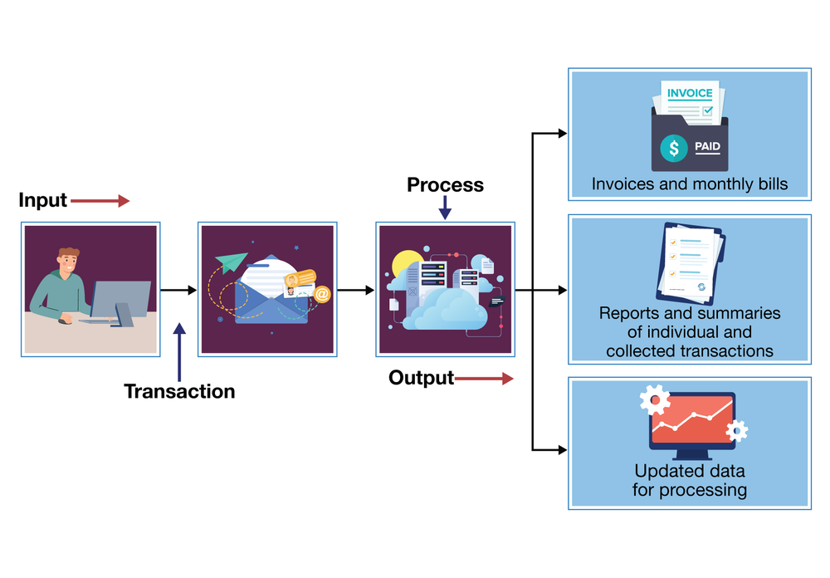
Sources: FlatWorld; © Shutterstock, Inc.

Process Control Systems
Process control
Application of technology to monitor and control physical processes.
refers to the application of technology to monitor and control physical processes. It’s useful, for example, in testing the temperature of food as it’s being prepared or gauging the moisture content of paper as it’s being manufactured. Typically, it depends on sensors to collect data periodically. The data are then analyzed by a computer programmed either to make adjustments or to signal an operator.

Design and Production Systems
As we saw in Chapter 8 “Operations Management in Manufacturing and Service Industries”, modern companies rely heavily on technology to design and make products. Computer-aided design (CAD)
System using computer technology to create models representing the design of a product.
software, for instance, enables designers to test computer models digitally before moving new products into the prototype stage. Many companies link CAD systems to the manufacturing process through computer-aided manufacturing (CAM)
System using computer technology to control production processes and equipment.
systems that not only determine the steps needed to produce components but also instruct machines to do the necessary work. A CAD/CAM system can be expanded by means of computer-integrated manufacturing (CIM)
System in which the capabilities of a CAD/CAM system are integrated with other computer-based functions.
, which integrates various operations (from design through manufacturing) with functional activities ranging from order taking to final shipment. The CIM system may also control industrial robots—computer-run machines that can perform repetitive or dangerous tasks. A CIM system is a common element in a flexible manufacturing system, which makes it possible to change equipment setups by reprogramming computer-controlled machines that can be adapted to produce a variety of goods. Such flexibility is particularly valuable to makers of customized products.

Management Support Systems
Mid- and upper-level managers rely on a variety of information systems to support decision-making activities, including management information systems, decision support systems, executive support systems, and expert systems.

Management Information Systems
A management information system

System used to extract data from a database and compile reports that help managers make routine decisions.

extracts data from a database to compile reports, such as sales analyses, inventory-level reports, and financial statements, to help managers make routine decisions. The type and form of the report depend on the information needs of a particular manager.

Decision Support Systems
A decision support system
Interactive system that extracts, integrates, and displays data from multiple sources to help managers make nonroutine decisions.
is an interactive system that collects, displays, and integrates data from multiple sources to help managers make nonroutine decisions. For example, suppose that a gaming company is considering a new casino in Pennsylvania. To decide whether it would be a wise business move, management could use a decision support system like the one illustrated in Figure 16.7. The first step is to extract data from internal sources to decide whether the company has the financial strength to expand its operations. From external sources (such as industry data and Pennsylvania demographics), managers might find the data needed to determine whether there’s sufficient demand for a casino in the state. The decision support system will apply both types of data as variables in a quantitative model that managers can analyze and interpret. People must make the final decision, but in making sense of the relevant data, the decision support system makes the decision-making process easier—and more reliable.
Figure 16.7 Decision Support System
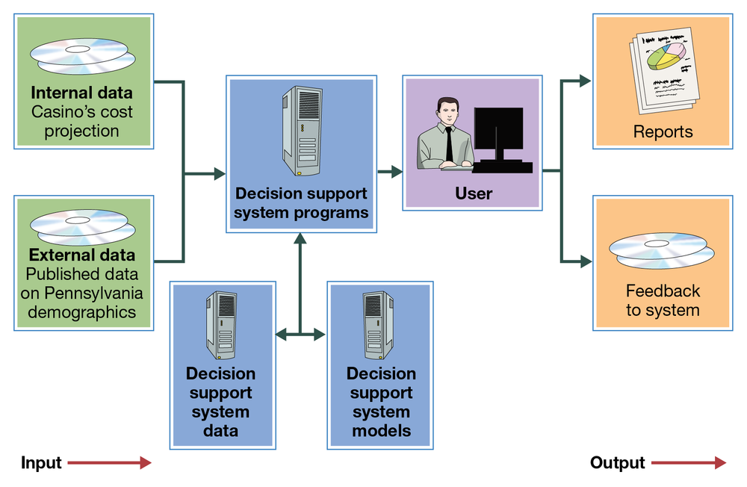
Source: FlatWorld

Executive Information Systems
As we observed in Chapter 5 “Managing for Business Success”, senior managers spend a good deal of their time planning and making major decisions. They set performance targets, determine whether they’re being met, and routinely scan the external environment for opportunities and threats. To accomplish these tasks, they need relevant, timely, and easily understood information. Often, they can get it through an executive information system
System that provides senior managers with strategic information customized to meet their needs and presented in a convenient format.
, which provides ready access to strategic information that’s customized to their needs and presented in a convenient format. Using an executive information system, for example, a gaming-company executive might simply touch a screen to view key summary information that highlights in graphical form a critical area of corporate performance, such as revenue trends. After scanning this summary, our executive can “drill down” to retrieve more detailed information—for example, revenue trends by resort or revenue trends from various types of activities, such as gaming, hotel, retail, restaurant, or entertainment operations.

Artificial Intelligence
Artificial intelligence
Science of developing computer systems that can mimic human behavior.
is the science of developing computer systems that can mimic human behavior. In the last two decades, significant advances have been made in artificial intelligence.
Numerous artificial intelligence applications have been successfully put to commercial use. Let’s take a brief look at two of these: expert systems and face-recognition technology.

Expert Systems
Expert systems
Program that mimics the judgment of experts.
are programs that mimic the judgment of experts by following sets of rules that experts would follow. They’re useful in such diverse areas as medical diagnosis, portfolio management, and credit assessment. For example, you’ve called the customer-service department of your credit card company because you want to increase your credit line. Don’t expect to talk to some financial expert who’s authorized to say yes or no. You’ll be talking to a service representative with no financial expertise whatsoever. They will, however, have access to an expert system, which will give you an answer in a few seconds. How does it work? The expert system will prompt the representative to ask you certain questions about your salary and living expenses. It will also check internal corporate data to analyze your purchases and payment behavior, and, based on the results, it will determine whether you get an increase and, if so, how much.
Type of System | Purpose of System | Example of System
Enterprise resource planning (ERP) system | Integrates computer needs of all enterprise activities into a single system serving all users | Press enter key to drop response here.  Response input area
Transaction processing system (TPS) | Records and processes daily activities on the level of transactions | Press enter key to drop response here.  Response input area
Process control system (PCS) | Monitors and controls physical processes | Press enter key to drop response here.  Response input area
Management information system (MIS) | Extracts data from databases to assist in compiling reports and making routine decisions | Press enter key to drop response here.  Response input area
Decision support system (DSS) | Collects and integrates data from multiple sources to help in making non-routine decisions | Press enter key to drop response here.  Response input area
Executive information system (EIS) | Provides access to strategic information that's customized for different managerial needs | Press enter key to drop response here.  Response input area
Expert system (ES) | Aids in decision making by following sets of rules that experts would follow and mimicking expert judgments | Press enter key to drop response here.  Response input area

Face-Recognition Technology
Face-recognition is a particularly interesting, and sophisticated, application of artificial intelligence. In the hotel-casino business, it’s crucial to identify and turn away undesirable visitors. One tool for this task is a digital camera-surveillance system that uses face-recognition technology. Using this technology, a program classifies a person’s face according to the presence/absence or extent of certain unique features, such as dimpled chins, receding jaws, overbites, and long or short noses. If there’s a match on, for example, fifteen features between a person being scanned and someone in the company database, a staff member decides whether the two people are the same. If a security manager then concludes that the face belongs to a skilled card-counter, the customer will be discouraged from playing blackjack; if it belongs to a known cheater, the individual will be escorted out of the casino. The system, however, does more than spot undesirables. It can also identify high rollers and send information about customers to managers on the floor. In this way, a manager can greet a preferred customer at the door with his favorite drink and a personalized greeting, such as “Hi, Bill! How’s Karen? Did you ever get that vintage Corvette? Here, have a gin rickey on the house.”

Key Takeaways
- Information needs vary according to managerial level (top, middle, or first-line).
- An IS, or information system, can be divided into two categories:
  - Those that meet the needs of low-level managers
  - Those that meet the needs of middle- and upper-level managers
- Low-level managers—those who run day-to-day operations and make routine decisions—use operations support systems, which usually fall into one of three categories: transaction processing systems, process control systems, and computer-aided design software.
  - Most daily activities are recorded and processed by a transaction processing system, which receives input data and converts them into output—information—intended for various users.
  - Process control refers to the application of technology to monitor and control physical processes, such as food preparation. The system depends on sensors to collect data for analysis by a computer programmed either to make adjustments or to signal an operator.
  - Technology can be used to design and make products. Computer-aided design (CAD) software, for instance, enables designers to test computer models digitally before moving new products into the prototype stage.
- Mid- and upper-level managers may use one of four types of management support system to assist in decision-making activities: management information systems, decision support systems, executive information systems, and expert systems.
  - A management information system extracts data from a database to compile reports, such as sales analyses, needed for making routine decisions.
  - A decision support system is an interactive system that collects and integrates data from multiple sources to assist in making nonroutine decisions.
  - To develop plans and make major decisions, managers may gather relevant, timely, easily understood information through an executive information system; an EIS provides ready access to strategic information that’s customized to their needs and presented in a convenient format.
  - An expert system mimics expert judgment by following sets of rules that experts would follow; it relies on artificial intelligence—the science of developing computer systems that can mimic human behavior.
Before going to the next section of this chapter, take a few minutes to take an online quiz to test your knowledge of the material covered in this section. Quizzes can be found by clicking on the Self-Study tab in the online reader.

Exercise
- For each of the following situations, select the appropriate management support system to aid the user: decision support system, executive support system, or expert system. In each case, describe the management support system that you recommend.
  - You’re trying to identify a rash on your arm.
  - You own two golf courses in the Northeast, and you’re thinking about building one in Florida. You need to gather and analyze information about your current operations in the Northeast, as well as external information about the golf industry in Florida.
  - You own three McDonald’s franchises. Every morning, you want to know the revenues and costs at each store. You’re also interested in a breakdown of revenues by product and costs by category of expense (salaries, food and ingredients, maintenance, and so on).

16.5 Computer Networks and Cloud Computing

Learning Objectives
- Describe the main systems for sharing information through networked computers.
- Compare and contrast a local area network (LAN) and a wide area network (WAN).
- Define “cloud computing” and identify its advantages and disadvantages.
- Discuss these categories of cloud computing: software as a service (SaaS), infrastructure as a service (IaaS), and platform as a service (PaaS).
Once it’s grown beyond just a handful of employees, an organization needs a way of sharing information. Imagine a flower shop with twenty employees. The person who takes phone orders needs access to the store’s customer list, as do the delivery person and the bookkeeper. Now, the store may have one computer, and everyone could share it. It’s more likely, however, that there are a number of computers (several for salespeople, one for delivery, and one for bookkeeping). In this case, everyone needs to be sure that customer records have been updated on all computers every time that a change is required.

Networks
Likewise, many companies want their personal computers to run their own software and process data independently. But they also want people to share databases, files, and printers, and they want them to share applications software
Software that performs a specific task, such as word processing or spreadsheet creation.
that performs particular tasks, including word processing, creating and managing spreadsheets, designing graphical presentations, and producing high-quality printed documents (desktop publishing).
The solution in both cases is networking—linking computers to one another. The two major types of networks are distinguished according to geographical coverage:
- A local area network (LAN)
- Network that links computers that are in close proximity.
- links computers that are in close proximity—in the same building or office complex. They can be connected by cables or by wireless technology. Your university might have a LAN system that gives you access to resources, such as registration information, software packages, and printers. Figure 16.8 illustrates a LAN that’s connected to another network by means of a gateway—a processor that allows dissimilar networks to communicate with one another.
Figure 16.8 Local Area Network (LAN)
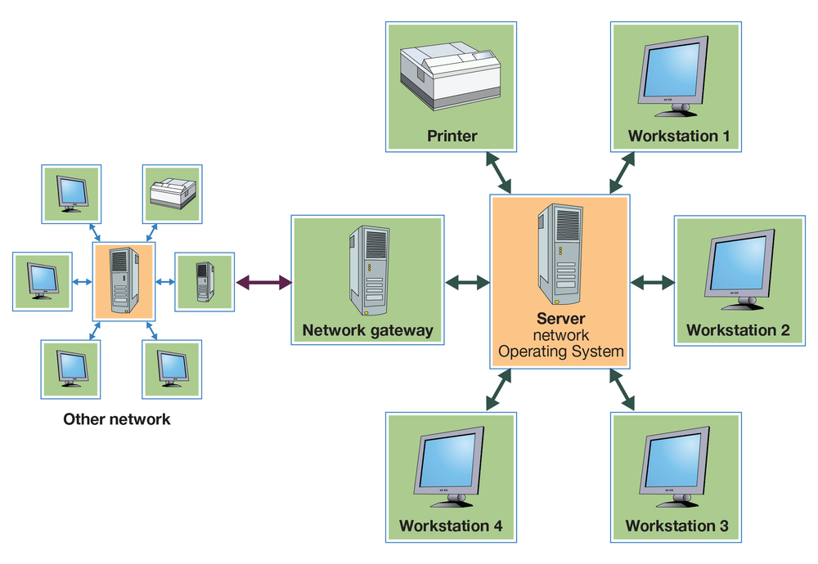
Source: FlatWorld
- Because a wide area network (WAN)
- Network that links computers that are spread over a relatively large geographical area.
- covers a relatively large geographical area, its computers are connected by telephone lines, wireless technology, or even satellite.
Like the one in Figure 16.8, some networks are client-server systems
System connecting client machines (which are used by employees for data input and retrieval) and a server (that stores shared databases and programs).
, which include a number of client machines (the ones used by employees for data input and retrieval) and a server (which stores the database and the programs used to process the data). Such a setup saves time and money and circulates more-accurate information.

Cloud Computing
The term “cloud computing
Cloud computing means performing computer tasks using services provided over the internet.
” means conducting computer tasks using internet-provided services. So how do you connect the two definitions? When IT professionals diagrammed computer systems, they used a cloud symbol to represent the internet. So when you hear or read that an individual or company is using the “cloud” or that technology firms, such as IBM, Hewlett-Packard, and Salesforce.com, are offering cloud services, just substitute the word “internet” for “cloud” and things will make sense.
You are probably already using the cloud—that is, if you use Facebook (which is very likely—in fact, just mentioning Facebook here might prompt you to stop studying and check out your friends’ pages). How do you know that Facebook is a cloud application? Remember the trick: just substitute the word “internet” for “cloud.” The Facebook computer application lets you store information about yourself and share it with others using the internet.

Business Applications
Think about the functional areas of business you’ve explored in this text: accounting, finance, human resources, management, marketing, operations, and product design. Now imagine you’re the chief technology officer for a company that owns twenty restaurants. You’re sitting at your desk when the CEO of your company gives you the news: your company just purchased a restaurant in Boston and made an offer to buy another restaurant in the nearby state of New Hampshire. This is good news for the company, but it means a lot of work for you and your staff.
You wonder whether this might be the time to outsource some of your computing tasks to a technology firm specializing in cloud computing. You remember an example that really makes sense: Right now, whenever Microsoft comes out with a new version of Word, your company has to pay $350 per computer for the latest version. Wouldn’t it make more sense to rent the use of the Microsoft Word program from a cloud vendor for say $5 a month (or $60 a year)? Given that the average time between new releases of Word is two years, your total cost per PC would be $120 (2 × $60)—a savings of about $230 per PC ($350 − $120). Your employees wouldn’t mind; instead of working offline, they would just log in to the internet and work with their online version using the files that were saved for them. And the members of your IT staff would be pleased that they wouldn’t need to install the new version of Word on all your computers.

The As-a-Service Group
Companies can contract for various cloud computing services. The Microsoft Word example discussed previously is classified as software as a service (SaaS)
The software as a service category of cloud computing gives companies access to a large assortment of software packages without having to invest in hardware or install and maintain software on its own computers.
. This type of service gives companies access to a large assortment of software packages without having to invest in hardware or install and maintain software on its own computers. The available software, which includes email and collaboration systems and customer relationship management programs, can be customized and used by an individual client or shared among several clients. A second type of service is called infrastructure as a service (IaaS)
A technology firm offering infrastructure as a service provides users with hardware, including servers, central processing units, network equipment, and disk space.
. Instead of providing users with software, a technology firm offering infrastructure as a service provides hardware, including servers, central processing units, network equipment, and disk space. The most popular IaaS provider is Amazon Web Services. The company rents computer power and storage to users, who access their data via the internet. The last as-a-service model is called platform as a service (PaaS)
Those offering the platform as a service category of cloud computing provide services that enable users to develop customized web applications.
. Those offering platform as a service provide services that enable users to develop customized web applications. Because they don’t have to start from scratch but rather build on existing platforms made available by the service provider, the web applications can be developed quickly.
What Is Cloud Computing?
Traditional business applications and platforms are too complicated and expensive. They need a data center, a complex software stack, and a team of experts to run them.
Transcript

Advantages and Disadvantages of Cloud Computing
In making your final decision (as the pretend chief technology officer for your company) you should consider the following advantages and disadvantages of cloud computing.

Advantages
Shifting some of your company’s IT functions to the cloud would produce a number of advantages:
- Cost Savings—By “renting” software rather than buying it, Caesars can reduce its costs. The monthly fee to “use” the software is generally less than the combined cost of buying, installing, and maintaining the software internally. On the hardware side, housing Caesars’s data in a service provider’s facilities, rather than in-house, reduces the large outlay of cash needed to build and maintain data centers.
- Speed of Delivery—Purchasing and installing software and data processing equipment can be time consuming. A cloud computing service provider could get Caesars’s applications up and running in only a few weeks.
- Scalable—Caesars is constantly expanding both in the number of casinos it owns and geographically. In this ever-changing environment, it’s difficult to gauge the level of our technology needs. If we overestimate our requirements, we end up paying for technology we don’t need. If we underestimate, efficiency goes down, and the experience for our customers diminishes. By using cloud computing we are able to have exactly what we need at our disposal at any point in time.
- Employees Can Be Mobile—The use of cloud computing will free workers from their desks and allow them to work wherever they are. As applications move to the cloud, all that is needed for our employees to connect to their “offices” is the internet. This mobility benefit also makes it easier for employees to collaborate on projects and connect with others in the company.
- Information Technology Staff—Although our current staff is extremely qualified and dedicated, finding experienced and knowledgeable staff is a continuing problem, particularly in the casino industry, which suffers from historically high turnover. By using cloud computing, we reduce our human resource needs by shifting some of our work to outside vendors who are able to hire and keep well-qualified individuals (in part because IT professionals enjoy working for technology companies).

Disadvantages
Although the advantages of moving to a cloud environment outnumber the disadvantages, the following disadvantages are cause for concern:
- Disruption in Internet Service—If Caesars moves some of its applications to the cloud, its employees can work on these applications on any device and in any location as long as they have an internet connection. But what if the internet is unavailable because of a disruption? Depending on the length of the disruption, this could create serious problems for Caesars.
- Security—Many companies are reluctant to trust cloud service providers with their data because they’re afraid it might become available to unauthorized individuals or criminals. This is a particular problem for Caesars, which collects and stores sensitive client information and has to constantly be on the lookout for fraudulent activity of staff and customers.
- Service Provider System Crash—Organizations considering moving to the cloud are justifiably concerned about the possibility of a computer service crash at their service providers’ facilities. It looks like this concern was warranted. In April of 2011, Amazon Web Service (a leading cloud services provider) experienced an outage in one of its large web-connected data centers. The outage crashed its system and brought down the websites of a number of companies, including the location-based social network Foursquare. It took more than thirty-six hours to get all seventy or so of the crashed sites up and running.

Go or No Go?
So, pretend chief technology officer, what’s your decision: will you get on the cloud or stay on the ground?

Key Takeaways
- Once an organization has grown to more than a few employees, it needs to network individual computers to allow them to share information and technologies.
- A client-server system links a number of client machines (for data input and retrieval) with a server (for storing the database and the programs that process data).
- Many companies want personal computers to run their own software and process data independently.
- But they also want individuals to share databases, files, printers, and applications software that perform particular types of work (word processing, creating and managing spreadsheets, and so forth).
- There are two systems that can satisfy both needs.
  - A local area network (LAN) links computers in close proximity, connecting them by cables or by wireless technology.
  - A wide area network (WAN) covers a relatively large geographical area and connects computers by telephone lines, wireless technology, or satellite.
- The term cloud computing means performing computer tasks using services provided over the internet.
- The software as a service (SaaS) category of cloud computing gives companies access to a large assortment of software packages without having to invest in hardware or install and maintain software on its own computers.
- A technology firm offering infrastructure as a service provides users with hardware, including servers, central processing units, network equipment, and disk space.
- Those offering the platform as a service category of cloud computing provide services that enable users to develop customized web applications.
- Shifting IT functions to the cloud produces a number of advantages, including cost savings, speedy delivery of software, scalability (you pay for only what you need), employee mobility, and a reduction in information technology staff.
- The following disadvantages of cloud computing are cause for concern: disruption in internet service, security issues, and unreliability of service provider systems.
Before going to the next section of this chapter, take a few minutes to take an online quiz to test your knowledge of the material covered in this section. Quizzes can be found by clicking on the Self-Study tab in the online reader.

Exercises
- What’s the difference between a LAN and a WAN? Give an example of the use to which each type of system can be put. Does your college maintain either type of computer network?
- In what ways could your college benefit from cloud computing? In responding, consider the three types of services offered by cloud service providers: software as a service, infrastructure as a service, and platform as a service. What type of security issues might your college administrators be concerned with?

16.6 Data Communications Networks

Learning Objectives
- Explain how four networking technologies—the internet, the World Wide Web, intranets, and extranets—make data communication possible.
- Identify and discuss reasons why businesses use the internet.
- Determine the difference between the internet, an intranet, and an extranet.
In addition to using networks for information sharing within the organization, companies use networks to communicate and share information with those outside the organization. All this is made possible by data communication networks
Large network used to transmit digital data from one computer to another using a variety of wired and wireless communication channels.
, which transmit digital data (numeric data, text, graphics, photos, video, and voice) from one computer to another using a variety of wired and wireless communication channels. Let’s take a closer look at the networking technologies that make possible all this electronic communication—in particular, the internet (including the World Wide Web), intranets, and extranets.

The Internet and the World Wide Web
Though we often use the terms internet and World Wide Web interchangeably, they’re not the same thing. The internet
Global network comprising smaller interconnected networks linking millions of computers around the world.
is an immense global network comprising smaller interconnected networks linking millions of computers around the world. Originally developed for the U.S. military and later adapted for use in academic and government research, the internet experienced rapid growth in the 1990s, when companies called internet service providers
Company that links into the internet infrastructure to connect paying subscribers.
were allowed to link into the internet infrastructure to connect paying subscribers. Today, internet service providers, such as Comcast and Verizon, enable us to use the internet to communicate with others through email, texting, instant messaging, online conferencing, and so on. These services also connect us with third-party providers of information, including news stories, stock quotes, and magazine articles.
The World Wide Web
Subsystem of computers on the internet that communicate with each other using a special language called HTTP.
(or simply “the web”) is just a portion of the internet—albeit a large portion. The web is a subsystem of computers that can be accessed on the internet using a special protocol, or language, known as hypertext transfer protocol (HTTP). What’s the difference between the internet and the web? According to Tim Berners-Lee (one of the small team of scientists who developed the concept for the web in 1989), the internet is a network of networks composed of cables and computers. You can use it to send “packets” of information from one computer to another, much like sending a postcard. If the address on the packet is accurate, it will arrive at the correct destination in much less than a second. Thus, the internet is a packet-delivery service that delivers such items as email messages all over the globe. The web, by contrast, is composed of information—documents, pictures, sounds, streaming videos, and so on. It’s connected not through cables, but rather through hypertext links that allow users to navigate between resources on the internet.
Because it’s driven by programs that communicate between computers connected to the internet, the web couldn’t exist without the internet. The internet, on the other hand, could exist without the web, but it wouldn’t be nearly as useful. The internet itself is enormous, but it’s difficult to navigate, and it has no pictures, sounds, or streamed videos. They exist on computers connected to the web, which also makes it much easier to retrieve information. The creation of web browsers
Software (such as Chrome) that locates and displays web pages.
—software, such as Google Chrome, that locates and displays web pages—opened up the internet to a vast range of users. Over 80 percent of individuals in the United States use the internet regularly. So, who’s in charge of the web? No one owns it, but an organization called the World Wide Web Consortium (W3C) oversees the development and maintenance of standards governing the way information is stored, displayed, and retrieved on it.

The Technology of the Web
Let’s look a little more closely at some of the technologies that enable us to transmit and receive data over the web. Documents on the web are called web pages, and they’re stored on websites. Each site is maintained by a webmaster and opens with a home page. Each web page is accessed through a unique address called a uniform resource locator (URL). For example, if you want to find statistics on football star Tom Brady, you could type in the URL address http://www.nfl.com/player/tombrady/2504211/careerstats. The prefix http:// is the protocol name, www stands for World Wide Web and is sometimes called the subdomain, nfl.com is the domain name, player the subdirectory name, and tombrady/2504211/careerstats the document name (or web page). A computer that retrieves web pages is called a web server
Computer that retrieves web pages.
. A search engine
Software program that scans web pages for specified keywords and provides a list of documents containing them.
is a software program that scans web pages containing specified keywords and provides a list of documents containing them. The most popular search engine is Google; others include Bing and Yahoo!
Figure 16.9
Google is the most popular search engine.

Source: Koshiro K/Shutterstock.com

Intranets and Extranets
What’s the difference between the internet, an intranet, and an extranet? It depends on who can and can’t access the information on the network. The internet is a public network that anyone can use. A company’s intranet
Private network using internet technologies that are available only to employees.
, meanwhile, is a private network using internet technologies that’s available only to employees; access is controlled by a software program called a firewall
Software program that controls access to a company’s intranet.
. The information available on an intranet varies by company but may include internal job postings, written company policies, and proprietary information, such as price lists meant for internal use only.
An extranet
Intranet that’s partially available to certain parties outside the organization.
is an intranet that’s partially available to certain parties outside the organization. Say, for example, you’ve posted the following information on your intranet: company policies, payroll and benefit information, training programs, parts specifications and inventories, and production schedules. To allow suppliers to bid on contracts, you might give them access to sections of the site disclosing parts specifications, inventories, and production schedules. All other sections would be off limits. You’d control access to employee-only and supplier-accessible sections by means of usernames and passwords. As you can reference in Figure 16.10, which illustrates some of the connections made possible by an extranet, access can be made available to customers and business partners, as well.
Figure 16.10 How an Extranet Works
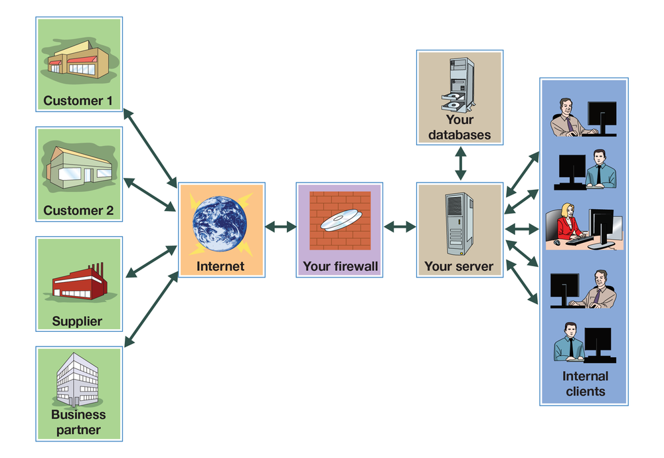
Source: FlatWorld

E-Commerce
The level of e-commerce
Business conducted over the internet.
—conducting business over the internet—varies by company. Some companies, such as Amazon, rely on the internet for their existence. Others, especially smaller firms, have yet to incorporate the internet into their business models, but these companies belong to a dwindling group: Most businesses have websites, and many businesses sell products through their websites. Having an online presence has become a standard practice for businesses of all sizes as it provides a platform for marketing, communication, and interaction with customers.

Why Businesses Use the Internet
Businesses use the internet for four purposes: presenting information, selling products, distributing digital products, and acquiring goods and services.
- Presenting information. By posting a website, a company can tell people about itself, its products, and its activities. Customers can also check the status of orders or account balances. Information should always be current, complete, and accurate. Customers should be able to find and navigate the site, which should be able to accommodate them during high-use periods.
- Selling products. Selling over the internet—whether to individuals or to other businesses—enables a business to enlarge its customer base by reaching buyers outside its geographical area. A company selling over the internet must attract customers to its site, make the buying process simple, assure customers that the site is secure, and provide helpful information.
- Distributing digital products. Some companies use the internet to sell and deliver such digital products as subscriptions to online news services, software products and upgrades, and music and video products. In these businesses, the timely delivery of products is crucial. Sales of digital products over the internet are expected to increase substantially in the future, particularly sales of digital music.
- Acquiring goods and services. E-purchasing (which was introduced in Chapter 11 “Operating in a Digital Marketing and Social Networking Environment”) saves time, speeds up delivery, reduces administrative costs, and fosters better communications between a firm and its suppliers. Most important, it cuts the costs of purchased products because it’s now feasible for buyers to request competitive bids and do comparative shopping. Many companies now use a technology called electronic data interchange
- Computerized exchange of business transaction documents.
- to process transactions and transmit purchasing documents directly from one IS to another. Figure 16.11 shows an electronic data interchange system at a company that subscribes to a value-added network—a private system supplied by a third-party firm—over which it conducts a variety of transactions.
Figure 16.11 Electronic Data Interchange System and Value-Added Networks
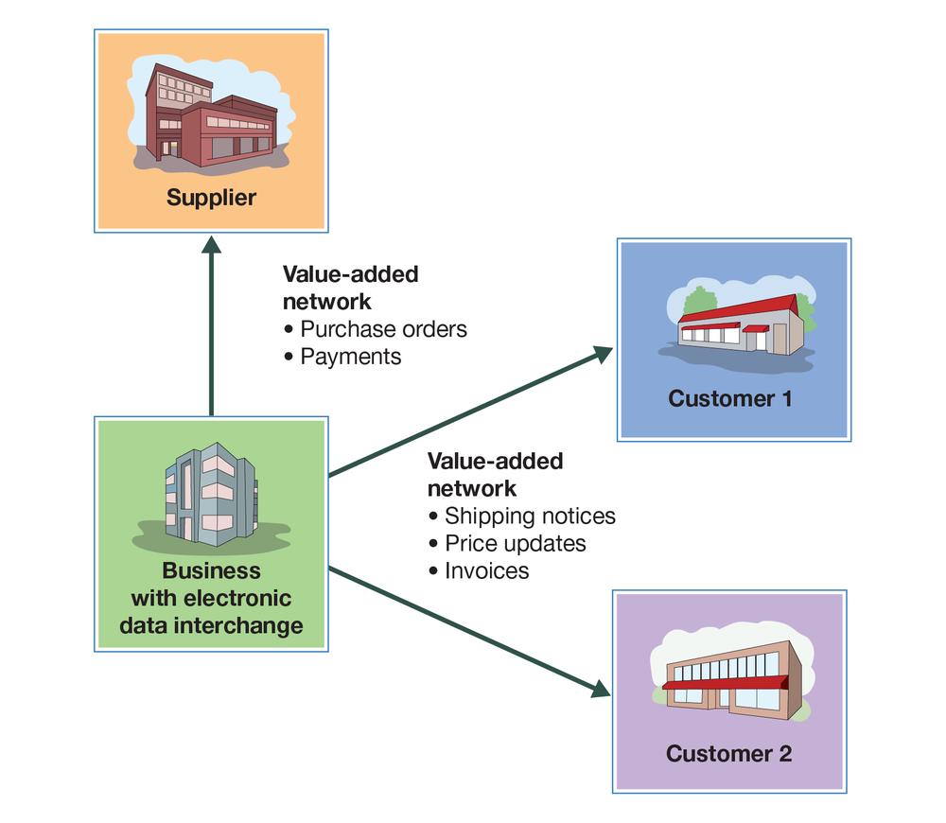
Source: FlatWorld

Key Takeaways
- Data communication networks transmit digital data from one computer to another computer using a variety of wired and wireless communication channels.
- One such network, the internet, is an immense global network of smaller interconnected networks linking millions of computers.
- By connecting paying subscribers into the internet infrastructure, a company called an internet service provider provides services, such as email, online conferencing, and instant messaging.
- A large portion of the internet, the World Wide Web (“the web”), is a subsystem of computers that can be accessed by means of a special protocol known as hypertext transfer protocol (HTTP).
- Computers on the web are connected with hypertext links that permit users to navigate among internet resources.
- A web browser is software that locates and displays web pages.
- A company’s intranet is a private network that’s available only to its employees; access is controlled by a software program called a firewall.
- An extranet is an intranet that’s partially available to certain outside parties, such as suppliers.
Before going to the next section of this chapter, take a few minutes to take an online quiz to test your knowledge of the material covered in this section. Quizzes can be found by clicking on the Self-Study tab in the online reader.

Exercises
- If asked by your instructor, how would you explain the difference between the internet and the World Wide Web?
- Identify ten specific ways in which your college uses the internet.

16.7 Security Issues in Electronic Communication

Learning Objectives
- Identify and discuss challenges faced by companies engaged in e-commerce, particularly in the area of security.
- Explain what a firewall does.
- Identify illegal activities companies face when conducting business over the internet.
- Explain how encryption is accomplished.
- Identify the purpose of a certificate authority.
E-commerce has presented businesses with opportunities undreamt of only a couple of decades ago. But it also has introduced some unprecedented challenges. For one thing, companies must earmark a substantial portion of their information technology budgets for protecting themselves against disrupted operations and theft due to computer crime and sabotage. The costs resulting from cybercrimes—criminal activity done using computers or the internet—are substantial and increasing at an alarming rate.
Some unfortunate companies, such as Target, have suffered costs considerably higher than that average. In December 2013, a group of criminals gained access to Target’s database and stole debit and credit card information belonging to 40 million people. Consumers were afraid their financial information (which was likely sold in the underground market) would be used by others and were, therefore, afraid to shop at Target. This resulted in a 46 percent decline in profits at Target during the critical holiday season. The company was under fire by consumer groups and lawyers representing banks that suffered losses due to credit card fraud. The cost to Target of the “holiday” cyberattack is estimated by some to be $1 billion.
It is common to worry about cybercrime when buying something online from internet companies such as Amazon, Overstock.com, or eTrade (an online discount stock brokerage service), but it is argued that the brick-and-mortar (physical) stores such as Target are more susceptible to cybercrime than the internet companies. Why might this be true? One reason is that the internet companies stake their reputations on being very careful with their customers’ financial information. Another reason is that cybercriminals can get a lot more financial information from a brick-and-mortar computer system than from an internet computer system. Internet companies often collect credit card information only, whereas brick-and-mortar companies capture additional financial information from their customers, such as Social Security numbers, household incomes, and so on.
According to the FBI’s 2022 annual Internet Crime Report, losses due to cybercrime in 2022 surpassed $10.3 billion. Most of these costs are absorbed by U.S. businesses, who either accept lower profits or push up prices to cover these added costs. In addition to protecting their own operations from computer crime, companies engaged in e-commerce must clear another hurdle: they must convince consumers that it’s safe to buy things over the internet—that credit card numbers, passwords, and other personal information are protected from theft or misuse. In this section, we’ll explore some of these challenges and describe a number of the efforts being made to meet them.

Data Security
In some ways, life was simpler for businesspeople before computers. Records were produced by hand and stored on paper. As long as you were careful to limit access to your records (and remembered to keep especially valuable documents in a safe), you faced little risk of someone altering or destroying your records. In some ways, storing and transmitting data electronically is a little riskier. Let’s look at two data-security risks associated with electronic communication: malicious programs and spoofing.

Malicious Programs
Some people get a kick out of wreaking havoc with computer systems by spreading a variety of destructive programs. Once they’re discovered, they can be combated with antivirus programs that are installed on most computers and that can be updated daily. In the meantime, unfortunately, they can do a lot of damage, bringing down computers or entire networks by corrupting operating systems or databases.

Viruses, Worms, and Trojan Horses
The cybervandal’s repertory includes “viruses,” “worms,” and “Trojan horses.” Viruses and worms are particularly dangerous because they can copy themselves over and over again, eventually using up all available memory and closing down the system. Trojan horses are viruses that enter your computer by posing as some type of application. Some sneak in by pretending to be virus-scanning programs designed to rid your computer of viruses. Once inside, they do just the opposite.
Viruses that can spread rapidly from computer to computer create enormous damage. It’s estimated, for example, that damage to 50,000 personal computers and corporate networks from the so-called Blaster worm in August 2003 totaled $2 billion, including $1.2 billion paid by Microsoft to correct the problem.

Spoofing
It’s also possible for unauthorized parties to gain access to restricted company websites—usually for the purpose of doing something illegal. Using a technique called “spoofing,” culprits disguise their identities by modifying the address of the computer from which the scheme has been launched. Typically, the point is to make it look as if an incoming message has originated from an authorized source. Then, once the site’s been accessed, the perpetrator can commit fraud, spy, or destroy data. You could, for example, spoof a manufacturing firm with a false sales order that seems to have come from a legitimate customer. If the spoof goes undetected, the manufacturer will incur the costs of producing and delivering products that were never ordered (and will certainly never be paid for).
Every day, technically savvy thieves (and dishonest employees) steal large sums of money from companies by means of spoofing or some other computer scheme. It’s difficult to estimate the dollar amount because many companies don’t even know how much they’ve lost.

Revenue Theft
In addition to the problems of data security faced by every company that stores and transmits information electronically, companies that sell goods or provide services online are also vulnerable to activities that threaten their revenue sources. Two of the most important forms of computer crime are denial of service and piracy.

Denial of Service
A denial-of-service attack does exactly what the term suggests: it prevents a web server from servicing authorized users. Consider the following scenario. Dozens of computers are whirring away at an online bookmaker in the offshore gambling haven of Costa Rica. Suddenly a mass of blank incoming messages floods the company’s computers, slowing operations to a trickle. No legitimate customers can get through to place their bets. A few hours later, the owner gets an email that reads, “If you want your computers to stay up and running through the football season, wire $40,000 to each of 10 numbered bank accounts in Eastern Europe.”
You’re probably thinking that our choice of online gambling as an example of this scheme is a little odd, but we chose it because it’s real: many companies in the online-gambling industry suffer hundreds of such attacks each year. Because most gambling operations opt to pay the ransom and get back to business as usual, denial of service to businesses in the industry has become a very lucrative enterprise.
Online gambling operations are good targets because they’re illegal in the United States, where they can’t get any help from law-enforcement authorities. But extortionists have been known to hit other targets, including Microsoft and the Recording Industry Association of America. The problem could become much more serious if they start going after e-commerce companies and others that depend on incoming orders to stay afloat.

Piracy
Technology makes it easier to create and sell intellectual property, but it also makes it easier to steal it. Because digital products can be downloaded and copied almost instantly over the internet, it’s a simple task to make perfect replicas of your favorite copyright-protected songs, movies, TV shows, and computer software, whether for personal use or further distribution. When you steal such materials, you’re cheating the countless musicians, technicians, actors, programmers, and others involved in creating and selling them. Theft cuts into sales and shrinks corporate profits, often by staggering amounts. Entertainment-industry analysts say 57 million Americans are downloading music illegally. That is one in five internet users.
So, what’s being done to protect the victimized companies? Actually, quite a lot, even though it’s a daunting task, both in the United States and abroad. In 1998, Congress passed the Digital Millennium Copyright Act, which outlaws the copying of copyright-protected music (unless you’re copying legally acquired music for your own use). The penalties are fairly stiff: up to five years in prison and $500,000 in fines. To show that it means business, the music industry is also hauling offenders into court, but legal action is costly and prosecuting teenage music lovers doesn’t accomplish much. Some observers believe that the best solution is for the industry to accelerate its own efforts to offer its products online. Initial attempts seem to be working. people who are willing to obey copyright laws have downloaded more than 25 billion songs from the iTunes site alone.

Firewalls
Builders install firewalls (or fireproof walls) in structures to keep a fire that starts in one part of a building from entering another part. Companies do something similar to protect their computer systems from outside intruders: they install virtual firewalls—software and hardware systems that prevent unauthorized users from accessing their computer networks.
You can think of the firewall as a gatekeeper that stands at the entry point of the company’s network and monitors incoming and outgoing traffic. The firewall system inspects and screens all incoming messages to prevent unwanted intruders from entering the system and causing damage. It also regulates outgoing traffic to prevent employees from inappropriately sending out confidential data that shouldn’t leave the organization.

Who Does the Most Hacking?
Have any of your accounts been hacked? Did you ever wonder what a profile of a hacker would look like? Complete an online exercise to find out.
How many computer hackers are techno-geeks? How many are industrial spies? How many are middle-aged, white-collar workers? At least one study shows that intruders usually come from one of the following four groups (plus “Others”).
As you can see from the chart, 58 percent of all breaches were committed by people from one of these four groups, 24 percent from those of another group, and so on. Which group do you think was responsible for the most breaches (and the greatest financial losses)? Drag and drop each item from the list to the label for the pie piece to which you think it belongs. (For example, if you think that "Competitors" were responsible for 58 percent of all breaches, drag and drop that item to the label of the “58%” pie piece).

Risks to Customers
Many people still regard the internet as an unsafe place to do business. They worry about the security of credit card information and passwords and the confidentiality of personal data. Are any of these concerns valid? Are you really running risks when you shop electronically? If so, what’s being done to make the internet a safer place to conduct transactions? Let’s look a little more closely at the sort of things that tend to bother some internet users (or, as the case may be, nonusers), as well as some of the steps that companies are taking to convince people that e-commerce is safe.

Credit Card Theft
One of the more serious barriers to the growth of e-commerce is the perception of many people that credit card numbers can be stolen when they’re given out over the internet. Though virtually every company takes considerable precautions, they’re not entirely wrong. Cybercriminals, unfortunately, seem to be tirelessly creative. One popular scheme involves setting up a fraudulent internet business operation to collect credit card information. The bogus company will take orders to deliver goods—say, Mother’s Day flowers—but when the day arrives, it will have disappeared from cyberspace. No flowers will get delivered, but even worse, the perpetrator can sell or use all the collected credit card information.

Password Theft
Many people also fear that internet passwords—which can be valuable information to cybercriminals—are vulnerable to theft. Again, they’re not altogether wrong. There are schemes dedicated entirely to stealing passwords. In one, the cyberthief sets up a website that you can access only if you register, provide an email address, and select a password. The cybercriminal is betting that the site will attract a certain percentage of people who use the same password for just about everything—bank accounts, email, employer networks. Having finagled a password, the thief can try accessing other accounts belonging to the victim. So, one day you have a nice cushion in your checking account, and the next you’re dead broke.

Invasion of Privacy
If you apply for a life-insurance policy online, you may be asked to supply information about your health. If you apply for a mortgage online, you may be asked questions about your personal finances. Some people shy away from internet transactions because they’re afraid that such personal information can be stolen or shared with unauthorized parties. Once again, they’re right: it does happen.

How Do “Cookies” Work?
In addition to data that you supply willingly, information about you can be gathered online without your knowledge or consent. Your online activities, for example, can be captured by something called a cookie. The process is illustrated in Figure 16.12. When you access a certain website, it sends back a unique piece of information to your browser, which proceeds to save it on your hard drive. When you go back to the same site, your browser returns the information, telling the site who you are and confirming that you’ve been there before. The problem is not that the cookie can identify you in the same way as a name or an address. It is, however, linked to other information about you—such as the goods you’ve bought or the services you’ve ordered online. Before long, someone will have compiled a profile of your buying habits. The result? You’ll soon be bombarded with advertisements targeted to your interests. For example, let’s suppose you check out the website for an online diet program. You furnish some information but decide that the program is not for you. The next time you log on, you may be greeted by a pop-up pushing the latest miracle diet.
Cookies aren’t the only form of online espionage. Your own computer, for example, monitors your internet activities and keeps track of the URLs that you access.
Figure 16.12 How Cookies Work
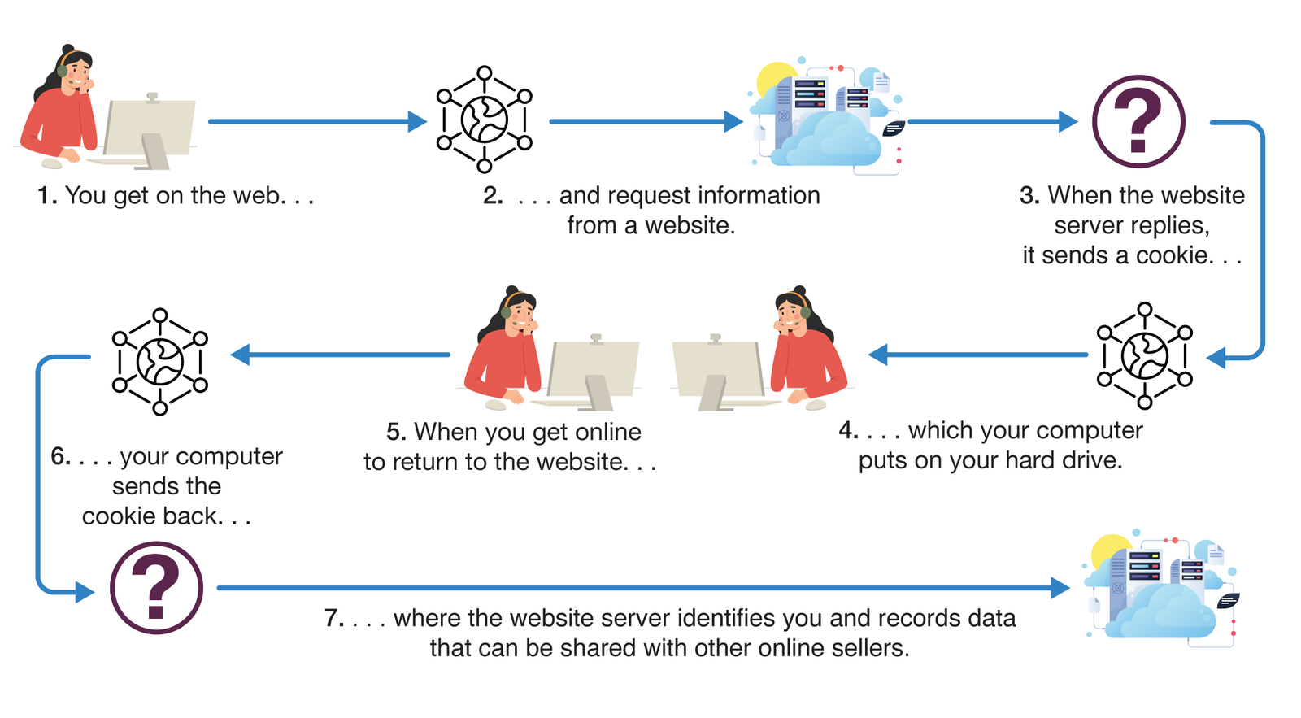
Sources: FlatWorld; © Shutterstock, Inc.

Shoring Up Security and Building Trust
So, what can companies do to ease concerns about the safety of internet transactions? First, businesses must implement internal controls for ensuring adequate security and privacy. Then, they must reassure customers that they’re competent to safeguard credit card numbers, passwords, and other personal information. Among the most common controls and assurance techniques, let’s look at encryption and seals of assurance.

Encryption
The most effective method of ensuring that sensitive computer-stored information can’t be accessed or altered by unauthorized parties is encryption
Process of encoding data so that only individuals or computers armed with a secret code (or key) can decode it.
—the process of encoding data so that only individuals (or computers) armed with a secret code (or key) can decode it. Here’s a simplified example: You want to send a note to a friend on the other side of the classroom, but you don’t want anyone else to know what it says. You and your friend could devise a code in which you substitute each letter in the message with the letter that’s two places after it in the alphabet. So you write A as C and B as D and so on. Your friend can decode the message, but it’ll look like nonsense to anyone else. This is an oversimplification of the process. In the real world, it’s much more complicated: data are scrambled using a complex code, the key for unlocking it is an algorithm, and you need certain computer hardware to perform the encryption/decryption process.

Certificate Authorities
The most commonly used encryption system for transmitting data over the internet is called secure sockets layer (SSL). You can tell whether a website uses SSL if its URL begins with https instead of http. SSL also provides another important security measure: when you connect to a site that uses SSL (for example, your bank’s site), your browser will ask the site to authenticate itself—prove that it is who it says it is. You can be confident that the response is correct if it’s verified by a certificate authority
Third-party vendor (such as VeriSign) that verifies the identity of a computer site.
—a third-party vendor (such as VeriSign) that verifies the identity of the responding computer and sends you a digital certificate of authenticity stating that it trusts the site.

What Web Shoppers Want
Do you conduct many purchases on the internet? Take a moment to complete an online exercise that lets you identify the features most web shoppers value. Then compare the most popular features with your own picks.
What features are most likely to attract you to a website as a suitable place to buy a product? What features do most internet shoppers value? Below is a list (in alphabetical order) of the top-six features mentioned by a recent survey of American online shoppers.
As you can see from the graph, one feature was mentioned by 90 percent of the respondents; the sixth-most-attractive feature appeared in 51 percent of their lists. Which feature was most valued and which was sixth? Drag and drop each item on the list onto the graph bar where you think it belongs. (For example, if you think that "Frequent-customer discounts" was the most highly valued feature, drag and drop that label onto the bar at the top.)

Key Takeaways
- Though a source of vast opportunities, e-commerce—conducting business over the internet—also presents some unprecedented challenges, particularly in the area of security.
  - Malicious programs, such as viruses and worms, can wreak havoc with computer systems.
  - Unauthorized parties may gain access to restricted company websites in order to steal funds or goods.
  - Firewalls—software and hardware systems that prevent unauthorized users from accessing computer networks—help to reduce the risks of doing business online.
- Companies that do business online are also vulnerable to illegal activities.
  - A denial-of-service attack, for example, prevents a web server from servicing authorized users; the culprit demands a ransom to stop the attack.
  - Companies that use the internet to create and sell intellectual property (such as songs, movies, and software) face the problem of piracy.
  - The theft of digital products, which can be downloaded and copied almost instantly over the internet, not only cheats the individuals and organizations that create them, but also reduces sales and shrinks corporate profits.
- Finally, online businesses must convince consumers that it’s safe to buy things over the internet—that credit card numbers, passwords, and other personal information are protected from theft.
- One effective method for protecting computer-stored information is encryption—the process of encoding data so that only individuals (or computers) armed with a secret code (or key) can decode it.
  - A commonly used encryption scheme is a secure sockets layer (SSL), which directs the user’s browser to ask a site to authenticate itself.
  - Often, the user receives a digital certificate of authenticity, verifying that a third-party security provider called a certificate authority has identified a computer.
Before going to the next section of this chapter, take a few minutes to take an online quiz to test your knowledge of the material covered in this section. Quizzes can be found by clicking on the Self-Study tab in the online reader.

Exercise
- Are you, or is someone you know, hesitant to buy things over the internet? What risks concern you? What are companies doing to ease consumers’ concerns about the safety of internet transactions?

16.8 Careers in Computer and Information Technology

Learning Objective
- Identify career opportunities in computer and information technology.
The number and variety of opportunities in the computer and information technology field have grown substantially as organizations have expanded their use of IT. Those choosing computer and information technology as a career will enjoy job security and generous pay. Employment in this field has been growing and is expected to continue to grow. Just as important, those choosing a career in computer and information technology will work in exciting fields such as cloud computing, artificial intelligence, machine learning, robotics, virtual reality, cyber security, Internet of Things, and video game creation.
In most large organizations, the senior management team includes a chief information officer (CIO) who oversees information and communications systems. A large organization might also have a chief technology officer who reports to the CIO and oversees IT planning and implementation
Most entry-level computer and information technology jobs require a bachelor’s degree in computer or information science. Many people supplement these majors with minors in business areas, such as accounting, finance, marketing, or operations management. Many computer and information technology managers also have a graduate degree.
If you’re starting out with a computer or information science degree, you may choose to follow either a management path or a technical path. At Kraft Foods, for example, IT professionals can focus on one of two areas: applications development (a management focus) or information technology (a technology focus). According to Kraft Foods, applications development professionals “participate in designing, coding, testing, implementing and supporting new systems,” while information technology professionals “provide the data, tools and capabilities to deliver core information services.” Despite the differences in focus, Kraft encourages IT specialists to develop expertise in both areas. After all, it’s the ability to apply technical knowledge to business situations that makes IT professionals particularly valuable to organizations.

Key Takeaways
- The number and variety of opportunities in the information systems (IS) field have grown substantially as companies have expanded their use of information technology.
- The senior management team in large organizations includes a chief information officer who oversees information and a chief technology officer who oversees IT planning and implementation.
- Most entry-level IS jobs require a business degree with a major in information systems.
- Many supplement their IS majors with computer science or some other business area, such as accounting, finance, marketing, or operations management.
- Those entering organizations with IS degrees may choose to follow either a management or a technology path.
Before going to the next section of this chapter, take a few minutes to take an online quiz to test your knowledge of the material covered in this section. Quizzes can be found by clicking on the Self-Study tab in the online reader.

Exercise
- Why is studying IT important to you as a student? How will competency in this area help you get and keep a job in the future?

16.9 Cases and Problems

Learning on the Web
Taking Care of Your Cyberhealth
It seems that some people have nothing better to do than wreak havoc by spreading computer viruses, and as a computer user, you should know how to protect yourself from malicious tampering. One place to start is by reading the article “How Computer Viruses Work,” by Marshall Brain, which you can access by going to the How Stuff Works website. After reading the article, answer the following questions:
- Why do people create viruses?
- What can you do to protect yourself against viruses?

Career Opportunities
Could You Manage a Job in IT or IS?
Do you have an aptitude for dealing with IT? Would you enjoy analyzing the information needs of an organization? Are you interested in directing a company’s internet operations or overseeing network security? If you answered yes to any of these questions, then a career in computer and information technology might be for you. Go to the U.S. Department of Labor website and learn more about the nature of the work, qualifications, and job outlook in computer and information technology. Bearing in mind that many people who enter the IT field attain middle-management positions, look for answers to the following questions:
- What kinds of jobs do computer and information technology managers perform?
- What educational background, work experience, and skills are needed for positions in computer and information technology management?
- What’s the current job outlook for computer and information technology managers? What factors drive employment opportunities?
- What’s the median annual income of a midlevel computer and information technology manager?

Ethics Angle
Campus Commando or Common Criminal?
Do you want to be popular (or at least more prominent) on campus? You could set up a website that lets fellow students share music files over the campus network. All you have to do is seed the site with some of your own downloaded music and let the swapping begin. That’s exactly what Daniel Peng did when he was a sophomore at Princeton. It was a good idea, except for one small hitch: it was illegal, and he got caught. Unimpressed with Peng’s technological ingenuity, the Recording Industry Association of America (RIAA) sued him, and he was forced to settle for $15,000. Instead of delivering music, Peng’s website now asks visitors to send money to help defray the $15,000 and another $8,000 in legal costs.
To learn more about the case, read these articles: “Suit settled for students’ downloading music online” and “Peng/RIAA case settled”.
After researching the topic, answer the following questions:
- The practice of sharing commercial music files is illegal. Do you think that it’s also unethical? Why, or why not?
- What steps to curb the practice are being taken by the music industry? By college administrators? By the government? Do you approve of these steps? Have they been effective?
- What, ultimately, do you see as the solution to the problem?

Team-Building Skills
CampusCupid.com
It’s no secret that college can be fun. For one thing, you get to hang around with a bunch of people your own age. Occasionally, you want to spend time with just one special someone, but finding that special person on a busy campus can take some of the fun out of matriculating. Fortunately, you’re in the same love boat with a lot of other people, so one possible solution—one that meshes nicely with your desire to go into business—is to start an online dating service that caters to your school. Since online dating is nothing new, you can do some preliminary research. For example, go to Stanford University News online and read the article “Meeting online has become the most popular way U.S. couples connect, Stanford sociologist finds,” by Alex Shashkevich.
Next, you and several of your classmates should work as a team to create a business model for an online dating service at your school. After working out the details, submit a group report that covers the following issues:
- Services. How will you earn revenues? What services will you offer? How will you price these services? What forms of payment will you accept? Will you sell ads? If so, what kinds?
- Appearance. What will your site look like? Will it have graphics? Sound? Video? What will your domain name be? What information will you collect from customers? What information will you provide to visitors?
- Operations. What criteria will you use to match customers? How will your customers interface with the website? How will they connect with each other? Will you design your own software or buy or lease it from vendors? Before you answer, go to the Dating Pro website and check out the features and benefits of their dating software.
- Attracting Customers. How will you attract customers to the site? How will you monitor and analyze site activity?
- Security. How will you guarantee confidentiality? How will you ensure that your site is secure? How will you limit access to students at your school?
- Opportunities and Challenges. What opportunities do e-businesses offer? What challenges do they create? How would your business model change if you decided to run it as a traditional business rather than as an e-business?

The Global View
Chinese Competitor to Amazon
When you think of buying online, you likely think of Amazon. But there’s another very powerful kid on the block—the Chinese company Alibaba. As Tricia McKinnon says in her article, “Alibaba’s Business Model—How the eCommerce Giant Makes Money,” Alibaba “is a mashup of Amazon, PayPal, eBay and Google.” Read McKinnon’s Indigo9 Digital article to learn more about this Chinese competitor to Amazon.
Also read the MyWallSt.com article, “The One Company That Could Be Amazon’s Biggest Threat” to learn how Alibaba may be the one platform that could challenge Amazon's dominance. Then, write a report that discusses these topics:
- How powerful is Alibaba? What has fueled its growth?
- Why do many believe Alibaba is a threat to Amazon?
- Do you believe Alibaba is a threat to Amazon? Why/why not?

